

Version 8.1.0

Version 8.1.0.073 | 26/08/2010
Modified tables | Created tables
None | None

New global variables for fillings: New global variables added for fillings:

_FillUg [ ] = Ug value for the glass unit, Dimension tab.
_FillPsiG [ ] = Value of the PsiG column from the warmedge, for the concerned glass thickness.
_FillLtTrans [ ] = Light Transmission value for the glass unit, Dimension tab.
_FillSolFac [ ] = Solar Factor value for the glass unit, Dimension tab.
_FillSpacer [ ] = Thickness of the first spacer for the glass unit, Dimension tab.
_ FillSpacer2 [ ] = Thickness of the second spacer for the glass unit, in case of triple glazing, Dimension tab.
_Fill2Ug [ ] = Ug value for the glass unit, Dimension tab, in case of Doubled Window (release note 8.1.0).
_Fill2PsiG [ ] = Value of the PsiG column from the warmedge, for the concerned glass thickness, in case of Doubled Window (release note 8.1.0).
_Fill2LtTrans [ ] = Light Transmission value for the glass unit, Dimension tab, in case of Doubled Window (release note 8.1.0).
_Fill22SolFac [ ] = Solar Factor value for the glass unit, Dimension tab, in case of Doubled Window (release note 8.1.0).
_FillSpacer [ ] = Thickness of the first spacer for the glass unit, Dimension tab, in case of Doubled Window (release note 8.1.0).
_FillSpacer2 [ ] = Thickness of the second spacer for the glass unit, in case of triple glazing, Dimension tab, and in case of Doubled Window (release note 8.1.0).

Those arrays are indexed onto FillingIndex variable. For values related to the thermic computation of the window, they are initialized only when your licence includes the Thermic Module ( TM ). Those variable may be usefull to retrieve thermic values onto CE Labels ( CE ), once again if your licence file includes this module (refer to release note 8.1.0).

Version 8.1.0.071 | 27/06/2010

Addition concerning packaging feature: For users of the Packaging Management feature, articles to be packaged are defaultly cumulated, enven when they don’t belong to the same window. You may disable this behaviour and not cumulate articles from distinct window anymore with creating a new key into Settings table:
[Packages]
Split Package By Window = 0 Articles cumulated (base behaviour, default).
= 1 Articles not cumulated.

Version 8.1.0.070 | 27/06/2010

Warm-edge pricing: The warmedge price is now impacted by insurance and discount from glass unit, for WinPro and WinPro/D.

Version 8.1.0.069 | 27/06/2010

Default creation for Settings table: When creating an empty database, or at the first update from this version, WinPro will create all Settings keys that does not exist, with default value.
A new section is also created allowing to restart this default creation process if necessary:
[Settings]
Imported = 0 Restart the process.
= 1 Does nothing (default value).

Version 8.1.0.068 | 27/06/2010

Price list for ventilators: You may now select all WinPro’s colours in addition to RAL colours, for price grid of the Price List tab of Ventilators.

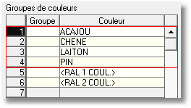

Version 8.1.0.066 | 27/06/2010

Creation of design including roller shutter: When the first created design of an order contains a roller shutter, if a new window is created, by default this window will also contain a roller shutter. You may now disable this behaviour through the following key into Settings table:
[Customer Order]
Copy Roller Shutter = 0 The roller shutter is not copied for the following windows.
= 1 WinPro copy the roller shutter for next window (default).

Cutting slot generation in case of fixed pane: You may now avoid the generation of a sash slot into the trolley for a fixed pane, using a new key into Settings table:
[Optimisation]
FixeSansCasier = 0 WinPro create a sash slot number for fixed panes (base behaviour, default).
= 1 WinPro does not create a sash slot number for fixed panes anymore.

Previously, slots were not generated for fixed panes by default, which involved problems in case of glazing bars and/or ventilators into the sash frame.

Questions with selection format: Selections from a question are now unaccessible for display or modification, until the concerned record (Outer frame, Sash frame, ...) is not edited using [F3] button.

Version 8.1.0.059 | 27/06/2010

Filter for module module Multi-CustInfo (INF module): When using module mutli-customer information generation for WinPro/D, customers codes are only listed for records filled in with a not null valuie for field “Number of WinPro/D copies”, into Commercial tab.

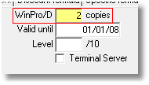

Refer to release note 8.01 for more details about this feature.

Version 8.1.0.053 | 27/06/2010

Printing options for thermic module: Addition of an option "Do not print thermic coefficient " within the Price tab when creating a customer order, using the following Settings key:
[Customer Order]
No printing thermic coefficient = 0 unchecked by default (base status).
= 1 checked by default.

The box remains modifiable straight into the Priice tab of the order, if required.

Extension of module Glass Multi Supplier: You may now set upt to 10 different supplier by glass unit (instead of 5 previously).

Version 8.1.0.051 | 27/06/2010

Window copy function fix: When copying a window from one order to another, fields DMELVOL and DMELCHA from Detail2 table are not copied anymore but are reset to zero value. Batching dates for window or roller shutter are then not copied anymore along with the design.

Pricing and printing option for WinPro/D: The following keys from Settings table are suitable for WinPro, and also now for WinPro/D:

[Optimisation]
%user%::Rep = Default status for checkbox « Discount per window », by user
%user%::Tot = Default status of checkbox « No total », by user

Refer to release not 7.1.13 for more details about those keys.

Version 8.1.0.045 | 19/08/2010
Modified tables | Created tables
None | None

Purge for customer documents export tables: The old key VidageTableExport from the [System] section will disappear using a version 8 of WinPro (release note 7.2.049). Another settings key is created for version 8, allowing the deletion of useless records into export tables (ART, CDE, FEN, DET, LIN & VAR).

[System]
VideTablesExport = The key controls when records from export tables are deleted or not if the corresponding order is deleted.
When set to 0, no record is deleted.
When set to 1, records are systematically deleted.
When set to 2, users are prompted to confirm deletion.

Version 8.1.0.039 | 27/06/2010

Overlapping outer frame and Thermic Module TM: Creation of an array global variable, _DeductionDormantReno [ ], indexed onto the outer frame side (Top, Bottom, Left, Right, TopLeft, TopRight).

This variable will contain the value (into mm) to be deduced to the outer frame width when computing needed surfaces for the thermic module.
This may e usefull in case of outer frame overlapping a wall, as detailled into below documentation :

Frames with special extensions overlapping the wall or other building elements, such as Z-shaped profiles, shall be treated in accordance with figure below. The part of the wall/building element is replaced by an adiabatic boundary. The width of the frame LInt used for the calculation of Uf is the total width of the frame LTot decreased by the distance overlapping the wall lrec.
This method can be applied to all profiles with special extensions (e.g. H-shape) where the extensions overlap the wall or other building elements.

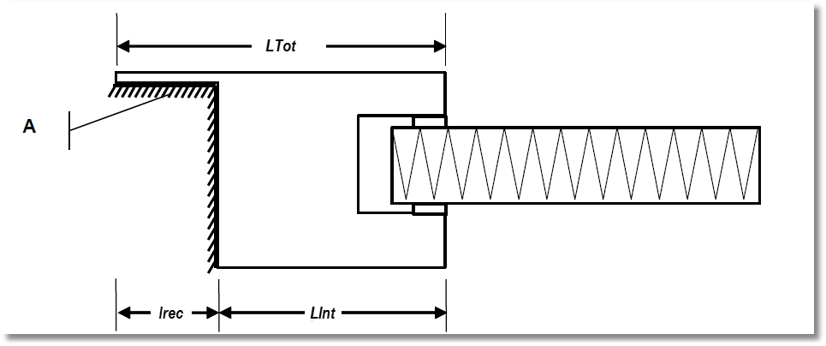

Roller shutter and Thermic Module TM: Creation of a global array variable _DesactiverCalculThermiqueVolet.
This variable indicates to WinPro not to compute elements of thermic calculation from a roller shutter.

Wood density introduced for Thermic Module TM: A new « Density » column is available into the various records representing combination of profiles for the thermic module (Frame + Sash, Frame + Fixed sash, etc).
This column may correspond to a density value of the wood essence. WinPro will retrieve this value now when computing for U value.

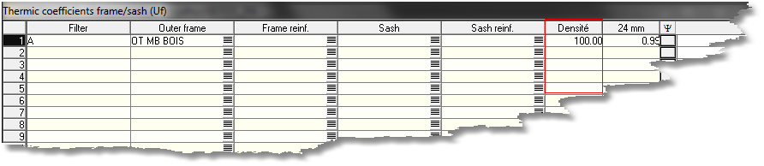

This density may be set up by the user for a given design through a new global variable labelled _Densite.
WinPro will look for the U value based on the combination of profiles and this density. When no correspondancy is found for a given density, the upper density value will be selected, if exists.

Density usage is optional.

Additional feature for optimization: A new key of Settings table is now enabled for optimization option.

[Optimisation]
Sorting profiles = 0 Default sort order for profiles (base behaviour).
= 1 Alternative sort method for profiles (sashes first).

When set to zero, profiles are sorted based onto fields LOT, SOUSLOT, SCIE and LIGNE from DetLot table (default sort order).
When set to 1, profiles are sorted based onto fields LOT, SOUSLOT, SCIE, DORMANT and LIGNE from Detlot table. Sash frames will then be handled first.

However, when using a profile into both sash and outer farmes at the same time, this sort method is no more reliable unless having error messages or machine driver problems.

Note: Those sort methods impact optimization documents as well as machine driver links, in case no sort method is applied at driver level.

Version 8.1.0.035 | 27/08/2010
Modified tables | Created tables
None | None

New WPREPORT function: The Sendmail (Subject : string; Text ; string ; Attachment: string ; ForMail ; string ; FromMail : string ; FromName ; string ; SMTPHost : string ; SMTPPort:integer ; Authentification : integer) : Boolaen function is designed to send a mail automatically to a given receiver, from a WPR report. This returns True when the email is correctly sent, False otherwise. The function uses the default mail client declared into the system.
- Subject subject of the mail (facultative but better when set).
- Text body of the mail (facultative but better when set).
- Attachment pat hand name of the file to be joined to the mail (facultative).
- ForMail email address of the receiver (imperative).
- FromMail email address of the sender (imperative).
- FromName name of the sender that will be displayed along with the address (facultative).
- SMTPHost name of the SMTP server used to send the mail (imperative).
- SMTPPort TCP port number of the SMTP server used to send the mail (facultative, port 25 by default).
- Authentification is worth 0 when the SMTP server does not require an authentification login to transfer the mail, 1 when the server requires it, then a user name and password will be prompted when the mail is sent (most often 0).

Example:
var
cpt : boolean;
cpt := Sendmail ('Subject of mail' , 'Mail body' , 'c:\attachedfile.txt' , 'receiver@ receiver.com' , 'sender@sender.com' , 'Sender name' , 'smtp.text.com' , 25 , 0);

This will return True or False into ’cpt’ variable, in case the mail is correctly sent or not.

Enhancements for DashBoard feature (TBC): Enhancement applied to the module (release note 8.02.x) :

- Option for "No total", from the Price tab of the order, is now available. In this case, the selling price displayed onto the dashboard will be null, and the gross makup will be set to -100.
- The 3 level of discounts from the Price tab of the order are now cumulated (Example : when discount1 = 50% and discount2 = 30%, displayed discount will be 65%).
- The "At" field into the date selection area id now initialized to the today date, when the dashboard is accessed for the first time in the session.
- The « Roller shutters number » column is moved near the « Windows number » column.

Version 8.1.0.027 | 27/07/2010

Import/Export of translations under Excel file: This new feature allows to import from an Excel file, or export to an Excel file, the translations of the database content.
This feature is available through 2 menu entries, Miscellaneous | Import from Xls | Translations along with menu Miscellaneous | Import from Xls | Translations.

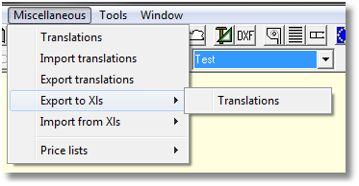

The export step is made of several processes. First, the user is invited to define the target location and file name of the Excel file containing the translations.
Après cette sélection, WinPro va rechercher toutes les traductions de la base de données et les ajoutera dans un ou plusieurs fichiers Excel.
You may consider that the maximum capacity of an Excel file is up to 65535 lines. Once this limit is reached, WinPro will create a new Excel file with the same name followed by a sequence number.

Note: First of all, WinPro will search for descriptions of each component of a window (article, outer frame, etc..). This description is considered as the default translation into the user language for this element. Then, WinPro will read the content of Traductions table and will update this list. Refer to release note 8.0 for more details about the translation system for the database content that has been put in place from version 8.

The import step is also composed of several processes. First, the user is invited to select the source Excel file to be imported.
Then, WinPro will load the content of the file into memory, and finally will check existing translations in order to add or update the translation records.

Version 8.1.0.012 | 27/06/2010

Thermic module tables into a technical export: Tables related to Thermic Module TM are now included into the technical export generated from menu Tools | Export technical database.

Syntax maintenance: The following global variables for fillings are renamed to leave the program uniform from a syntax point of view:

Original name (French) Renamed as (French) English version

_CouleurCrx [ ] => _RemplCoulCrx [ ] => _GBarColour [ ]
_CouleurCrx2 [ ] => _Rempl2CoulCrx [ ] => _GBar2Colour [ ]
_CouleurCrxInt [ ] => _RemplCoulCrxInt [ ] => _GBarIntClr [ ]
_CouleurCrxInt2 [ ] => _Rempl2CoulCrxInt [ ] => _GBar2IntClr [ ]
_CouleurIntercalaire [ ] => _RemplCoulIntercalaire [ ] => _FrameClrCateg [ ]
_CouleurIntercalaire2 [ ] => _Rempl2CoulIntercalaire [ ] => _Frame2ClrCateg [ ]

Version 8.1.0.xxx
Compatibility 7.2 | No

Addenum concerning Bull’s eye shapes: The bull’s eye shape of design is proposed by the program since version 1, but the following features are not supported yet:

- No support for glazing bars
- No support for sash/outer frame transoms

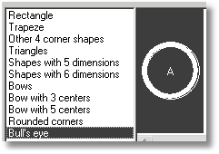

Those features will be available for such a shape with version 8.2 of WinPro.

Introduction

WinPro version 8.1.0 introduces 3 new features:
- Warm edges management (thermal spacer for sealed units)
- Thermic calculation following European norms
- Input and calculation functionalities for double windows (two windows within the same outer frame)
-  marking feature

Warm edges

Definition
A warm edge is a new type of spacer for glass sealed units, granting a better thermal insulation than the classic aluminium spacer, as a classic spacer is already a thermic bridge around the glass unit.
The warm edges have to be defined in order to calculate the involved additional cost. They also have a great impact within the thermic module, even if you can use warm edges without the thermic module.
Attention! If you define at least one warm edge type, you will also have to define the standard aluminium spacer as a warm edge. Indeed, when at least one warm edge is defined, WinPro will control that the selected glass unit is compatible with the chosen warm edge
Moreover, when at least one warm edge is defined, you will have to assign at least one warm edge for each glass unit into the file!!!
If some specific glass units cannot contain a warm edge, then a ‘dummy warm edge’ should be assigned to those glass units.
The warm edge management dialog even contains a button allowing the user to define a warm edge for the overall glass file.
The warm edges may be defined at two levels: first into a table of warm edges, where the code, description, price and Ψ coefficient (optional in case you do not use the thermic module) are set; secondly warm edges may be set into glazing table: for every glass unit, define there if a given warm edge is allowed or not for the specified sealed unit.

Warm edges set up

Warm edges table
This table is reached through menu Technic | Windows | Warm edges.
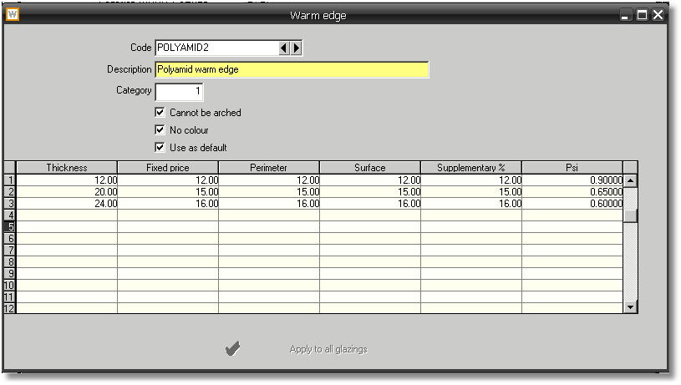
- Code : code assigned to the warm edge
- Description : description of the warm edge
- Category: numeric value updating a variable WarmEdge within glazing formulas.
- Cannot be arched: check this box when the warm edge cannot be used within an arched shape.
- No colour: check this box if the warm edge cannot be painted on demand. When the user input a specific colour for spacer with a no colour warm edge, no error message will be shown, glazing prices won’t be be added with additional price for coloured spacer, and the specific colour for spacer won’t be mentioned onto any document.
- Use as default: check this box for the warm edge to be used by default, in case no warm edge is defined at order input level. If the existing default value is modified, WinPro will show a dialog to confirm the modification.
- The array allows to set the prices according the warm edge thickness, along with the Ψ coefficient by default for the thermic computation of the window.
- Thickness: thickness of the spacer considered for the price and the Ψ coefficient of the line.
- Fixed price: additional fixed price, by glass unit.
- Perimeter: additional fixed price according glass unit perimeter (by meter).
- Surface : additional fixed price according glass unit surface (by square meter).
- Supplementary % : percentage of additional fixed price to be applied to the glass unit (calculated first before calculation of others additional prices for the warm edge).
- Psi: Ψ coefficient applied when the warm edge is used; this is a default value: in case another value is defined for the combination of profiles, glass thickness, U_{g} coefficient and for this warm edge, this last value will be used.
- Apply to all glazings: use this button for the displayed warm edge to be assigned to every existing glazing in the file. A message box will be displayed for confirmation before proceeding. This operation may last a time according the glazing file size into the database.

Glass units table
Warm edges tab: displays the list of available warm edges; if at least one warm edge is defined, you should select the warm edge(s) compatible with the glass unit.

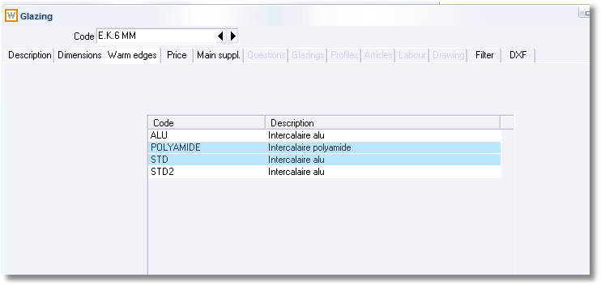

Configuration array variable
A new configuration array variable is available concerning warm edges. It returns the category value of a given warm edge for each filling:
_FillWarmEdge[]
This variable works the same way as the others configuration variables related to fillings.
When the corresponding filling is not a glass unit, and then cannot include a warm edge, this variable will return zero for this filling.

Warm edges usage

Input
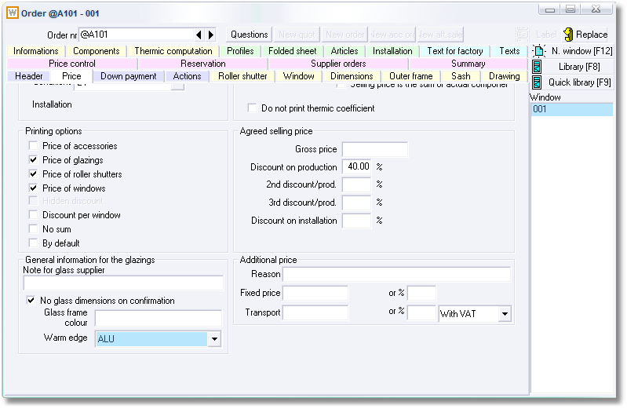
You may globally change the warm edge type for the overall order, using the Warm edge combo at the bottom left of the dialog. Be careful in case you defined a specific warm edge by level, either at design level or at glass unit level, this last one warm edge will be the one considered by the software. The correct warm edge is anyway displayed, at glass description level as well as at detail level of thermic calculation.
You may also input a warm edge for a given design in the order, using button nearby the sealed unit code. You may finally redefine the warm edge for a particular glass unit, using the ‘Modify glazing’ context menu (right click into a glass unit).

EDI for glass units
At this current day, we still have received no communication from glass suppliers concerning changes involved by those norms and calculation onto the EDI for glass units. We stay at your disposal for the necessary modifications if required, in collaboration with your suppliers.

Thermic module

Definitions
This module allows you to calculate the coefficient of thermic dissipation of a design, labelled U_{w} value.
An U_{ws} value will also be calculated when required: this value is the coefficient of thermic dissipation of a design with integrated roller shutter, when the curtain is shut.

Windows and doors
For each filling, WinPro will determine the profiles surrounding it: couples of outer frame-sash frame, transom-sash frame, single outer frame when fixed pane, single transom when fixed pane, sash frame-French mullion, sash frame-door sill, sash frame-kaltefeind. An Uf value also needs to be assigned to each of those profile groups, taking in consideration when the profile is reinforced or not (for PVC). Then, WinPro calculates the surface of the profile group determined, and multiply the thermic coefficient assigned to the group by this surface. Regarding transoms, note that the surface is evaluated reaching the axis.
The result found is added to the thermal calculation for glass units, obtained by multiplying the visible surface of glazing by their respective thermic coefficient.
Finally is added a peripheral coefficient, proper to each combination of glazing-profile, multiplied by the perimeter. The perimeter considered here is the visible perimeter of the glass unit.
The main formula is then the following:
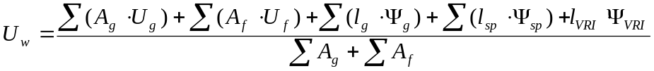
- A_{g} is the surface of each glass unit, panel unit or ventilator (into m²)
- U_{g} is the thermic coefficient of each glass unit, panel unit or ventilator
- A_{f} is the surface of profiles (into m²) adjacent to a side of a glass unit
- U_{f} is the thermic coefficient of each profile group adjacent to a side reaching a glass unit
- l_{g} is the perimeter of each glass unit, panel unit or ventilator (into m)
- Ψ_{g} is the peripheral thermic coefficient, depending on the glass unit, panel unit or ventilator, and depending on the adjacent profiles combination
- l_{Sp} is the glazing bars length (into m)
- Ψ_{sp} is the thermic coefficient for glazing bars
- l_{VRI} is the width of the roller shutter box
- Ψ_{VRI} is the thermic coefficient of the roller shutter box

Further in the document, values U_{g}, U_{p}, U_{a} will be distinguished respectively for glass units, panel units and ventilators. Same thing with values Ψ_{g}, Ψ_{p}, Ψ_{a} related to peripheral coefficients. Nevertheless, calculation methods remain similar for all those values.

Boxes for integrated roller shutter
When a window is calculated with an integrated roller shutter, the box affects the thermic performance of the design. For this calculation, 3 settings need to be defined:
- Insulation of the box panels: not insulated, insulated panel installed on lintel, 3 panels insulated
- Location of the shutter box: in contact with the outside environment or hidden behind the frontage
- Ventilation : average (remaining slot at the inferior side of the shutter <= 10mm) or strong (remaining slot at the inferior side of the shutter > 10mm)
Once those 3 values identified, a linear normalized value (Ψ) is applied, according the following table:
Table 1
Installation of the roller shutter box | Insulation of the shutter box panels | Ψ_{VRI} (W/mK)
Installation of the roller shutter box | Insulation of the shutter box panels | Average ventilation | Strong ventilation
In contact with outside environment | Not insulated | 0,34 |  | 1,10
In contact with outside environment | 1 panel insulated (on lintel) | 0,19 |  | 0,90
In contact with outside environment | 3 panels insulated |  |  | 0,90
In contact with outside environment | 3 panels insulated |  |  | 0,40
Integrated behind frontage | Not insulated | 0,30 |  | 1,50
Integrated behind frontage | 1 panel insulated (on lintel) | 0,18 |  | 1,10
Integrated behind frontage | 3 panels insulated |  |  | 1,10
Integrated behind frontage | 3 panels insulated |  |  | 0,45
The Ψ_{VRI} value found will be multiplied by the box width (into m), and added to the total U_{w} value for the design, before dividing the result by the design surface (excluding the shutter box surface). See formula in the previous page

Curtains for integrated roller shutters
If the design is produced with an integrated roller shutter, a second thermic value will be calculated specifically for the thermal value of the design with closed curtain. This value will be labelled U_{ws} and supplied complementary with the U_{w} value.
In order to calculate this U_{ws} value, the following values need to be known:
- b_{sh} : clearance left between the edges of the closed curtain and masonry. This value is the sum of bottom clearances (labelled b₁), top clearances (labelled b₂) and lateral clearances (here is considered the average of lateral clearances for both sides, labelled b₃). b_{sh} value is then the sum of b₁ + b₂ + b₃
- R_{sh} : thermic resistance of the curtain itself
Both values allow then to calculate a ΔR value, according the following array:
Table 2
Classe | Air permeability of the roller shutter in closed position | b_{sh} (mm) | ΔR (m²K/W)
1 | Very high permeability | b_{sh} > 35 | 0,08
2 | High permeability (the roller shutter itself is impermeable to air) | 15 < b_{sh} ≤ 35 | 0,25 . R_{sh} + 0,09
3 | Average permeability (the roller shutter itself is impermeable to air) | 8 < b_{sh} ≤ 15 | 0,55 . R_{sh} + 0,11
4 | Low permeability (the roller shutter itself is impermeable to air) | b_{sh} ≤ 8 | 0,80 . R_{sh} + 0,14
5 | Very low permeability (the roller shutter itself is impermeable to air) | b_{sh} ≤ 3 et (b₁+b₃ = 0 or b₂+b₃ = 0) | 0,95 . R_{sh} + 0,17

With the ΔR value obtained, the above formula can be applied:

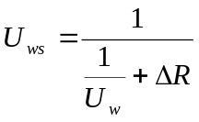
- U_{ws} is the thermic value of the window when curtain is shut
- U_{w} is the thermic value of the window calculated as described above
- ΔR is the thermic value of the roller shutter itself when shut, as described previously.

Calculation for profiles surfaces
WinPro knows the basis surface of the profiles, considering dimensions HxW, overlapping and clearances values set. The computed surface will vary automatically in case of variable overlapping, variable section, etc., as this corresponds to the calculation norm of the thermic dissipation.
WinPro will compute the profiles surfaces aiming that the sum of those surfaces added to the sum of the fillings surfaces corresponds to the total surface of the design. The following cases are considered during computation:
Design corner: surface of the corner is calculated; for each edge of the corner, half of this surface is considered
Transom: for an assembly join with a sash or outer frame, the transom surface is stopped at the most inside edge of the sash or outer frame. When joined to another transom, the surface of the junction between both transoms is calculated, and half of this surface is allocated to each transom. Attention, transom are always calculated based onto half of its width, as both sides of the transom will be processed anyway to obtain the full width.
French mullion: the surface of the sash side corresponding to the French mullion is fully evaluated; surface of attached profiles is stopped at the most inside edge of the sash profile.

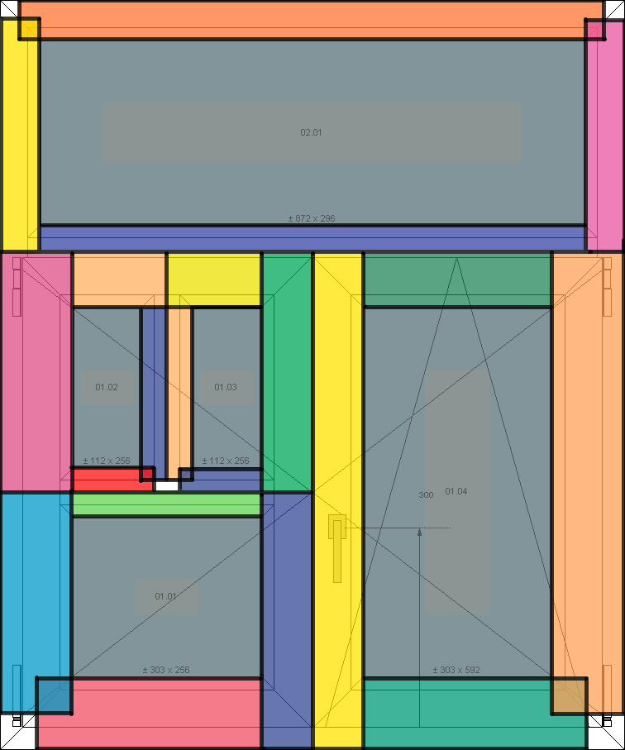
Aside drawing shows a sample of surfaces cutting out. Each surface has a different colour than its neighbour. The list of surfaces computed is available into the ‘thermic calculation’ tab of the order.

Double windows
WinPro 8.1 will also offer features for double windows calculation, meaning 2 windows in front of one another (parallel) into the same outer frame. Refer to the en of the chapter for more details about this.
For such windows, WinPro calculate thermic values as follows:
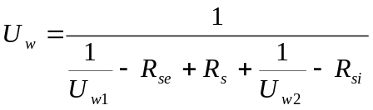
- U_{w1} and U_{w2} are the U_{w} coefficients for inside and outside windows, calculated individually by the program for each semi-window.
- R_{se} is the thermic resistance of exchange for the outside surface of the window from the inside. Basically this value is set to à 0,04
- R_{si} is the thermic resistance of exchange for the inside surface of the window from the outside. Basically, for vertical windows, this value is set to 0,13. WinPro will only consider this case. The value is 0,10 for windows installed with an angle of more than 60°, but the program will not consider this case.
- R_{s} is the thermic resistance of the space gap separating both windows, determined according table 3. The default value assigned to this setting by WinPro is 0.163 (most disadvantageous case). You may modify this value with modifying a global variable labelled _Rs.

Table 3
Thickness of the space gap (mm) | Glass unit with coating on one side, normal emissivity (εn) equal |  |  |  | Glass unit without coating(εn=0,89)
Thickness of the space gap (mm) | εn = 0,1 | εn = 0,2 | εn = 0,4 | εn = 0,8 | Glass unit without coating(εn=0,89)
50 | 0,406 | 0,336 | 0,260 | 0,189 | 0,179
100 | 0,376 | 0,315 | 0,247 | 0,182 | 0,173
300 | 0,333 | 0,284 | 0,228 | 0,171 | 0,163

As R_{se} and R_{si} values are constant, WinPro simplify the formula as follow :

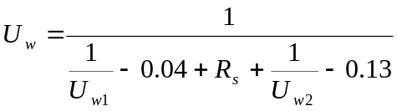

Please note that, according this formula, it is not necessary to know which window is inside or outside, the formula is anyway evaluated the same way whatever the case is.

Thermic module set up
This set up is relatively simple and does not require a good knowledge of WinPro as it only consists in filling a various number of lists of values; WinPro only applies standardized formulas onto the values.

Thermic coefficient menu
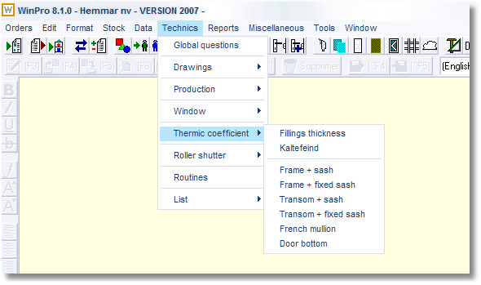
A sub menu within the Technic menu gives an access to the main settings for thermic computation.

Fillings thicknesses
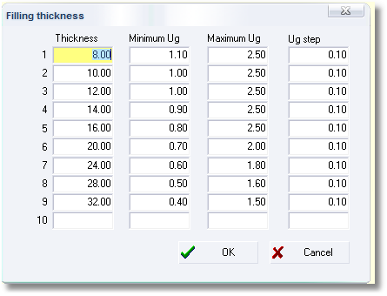
This dialog allows you to set up the glass or panel units thicknesses in use. For each thickness, you may define the U_{g} (thermic coefficient for glass unit) or U_{p} (thermic coefficient for panel unit) values that you need in order to limit the set up of the detailed Ψ values (peripheral thermic coefficient for fillings).
If a filling with intermediate thickness is found, the program will select the immediately below value, for the computation needs. If the glass thickness is less than the lower thickness set, WinPro will generate a computation error for the U_{w} value.

Kaltefeinds
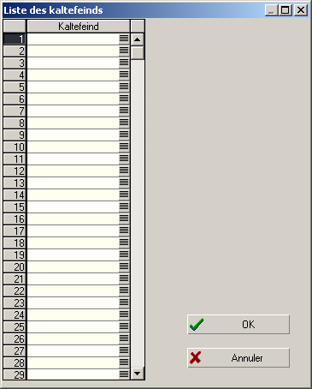
This dialog allows you to set the liste of article code for kaltefeinds. WinPro will then look for a potential kaltefeind consumed along with the bottom profile of a door, in order to compute correctly the thermic value.

Frame + sash
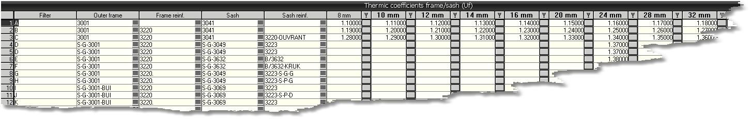You may define using this dialog the thermic values for outer frame / sash frame pairs of profiles.
A Filter column may be set with an arbitrary value for each line. Those values will filter the liste of U coefficient to display when the menu is accessed.
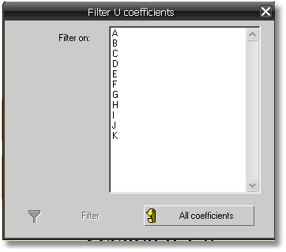
The user may use this dialog to filter the list of values to display, or may also display the whole liste using button

Within this frame + sash dialog, set a distinct line for each combination of profiles, reinforced or not (for PVC designs), with the nature of the reinforcement, as reinforcement has a valuable involvement into thermic performance of profiles.
For every combinations of outer frame / sash frame / reinforcement profile(s), a thermic value should be defined in function of the filling thickness. In case of null value, WinPro will generate an error when this value is absolutely needed.
A button may be used nearby each thermic value (Ψ column), giving access to the table of detailed peripheral values for fillings. The table is optional thanks to the ability to set a default Ψ value at the warm edges level or at the fillings categories level. Nevertheless those default values would be penalizing for the calculation compared to detailed values; it is then better to set complete Ψ values if they are known, for the most accurate computation possible.
In fact, each Ψ values depend on the following settings:
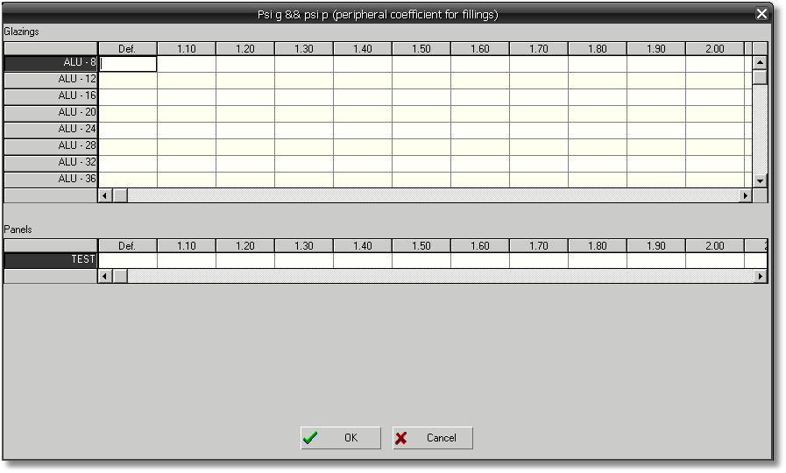
- Profiles combination
- Filling thickness
- Filling type (glass or panel unit). There is a table for glass units, and a table for panels.
- Potential warm edge (glazing spacer), or panel category
- U_{g} coefficient for glass unit or U_{p} for panel unit. When an intermediate value U_{g} or U_{p} is found regarding values defined in the table, the Ψ default value from the warm edge or panel category will be used instead (when a value is set for this particular spacer thickness into the warm-edge, otherwise WinPro returns a computation error).

Each line of the Ψ value array includes a column labelled ‘Def.’, corresponding to a default value for the considered line.
The search algorithm for Ψ value is detailled below:
- WinPro tries first to find the Ψ value exactly matching the glazing type (thickness, U value, spacer thickness) along with the group of profiles considered.
- In case of no match found, the program checks if a default value is set for the same considered line of Ψ value.
- If no default value has been set, the program jump to the Ψ value line of the same array, for the same warm-edge reference, but for a spacer thickness immediately inferior (if exists).
- If for this line, a U value is set for the considered glazing, the program uses it.
- If for this line, no U value is set for this glazing, the program uses the defaul value set for this line.
- If no default value is set for this line, the program restart at point 3, until eventually all spacer thickness values inferior to the targeted thickness have been reviewed.
- When no match is found after all spacer thicknesses are checked, WinPro fetches the default value from the warm-edge for the considered spacer thickness of the glass unit. Attention, the algorithm will look for the exact spacer thickness into the warm-edge, it won’t look for an inferior value for the spacer as for the detailled Psi values !
- If, at this stage, this value is not set, WinPro returns an error value.

Important note:
The set up of a Ψ for every combination is a long time spending work, but maybe be optionnal. Indeed, as soon as a Ψ default value is set at the warm edge and panel category levels, WinPro has the ability to compute the thermic dissipation coefficient for the window. You may then skip this stage, setting nothing into the array, or only set up values that are the most often me .Anyway, be aware that the default Ψ value is generally the less favorable value; then if you only work with default value, the final result will also be less favorable!

Frame + fixed sash
This dialog works the same way as the frame + sash dialog, but for a single outer frame (fixed pane). You should set here the outer frame and its reinforcement profile (when required), along with the various thermic values according the filling thickness.

Transom + sash
This dialog is similar to the frame + sash dialog, with replacing outer frames with transoms.

Transom + fixed sash
This dialog is used similarly to the frame + fixed sash dialog, with replacing outer frames with transoms. It also allows users to set values for sash transoms (same values in fact in case outer frame transoms and sash transoms are identical).

French mullions
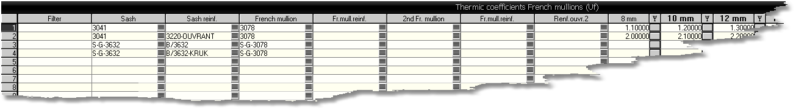This dialog is similar to frame + sash one, but for French mullions. It has to be set with sash frame code along with its reinforcement profile, as well as the French mullion code along with its potential reinforcement profile too, for any profile combination of sash + French mullion, in order to clear any ambiguity.
To visualize calculation method, below is the program algorithm:
- For the sash frame side corresponding to the French mullion, the program fetches the sash profile code used (and its potential reinforcement profile)
- Then, for the same side of the same leaf, the program will look for an existing French mullion profile category. If exists, WinPro stored it internally, along with its potential reinforcement profile reference.
- The program then search for a French mullion profile into the corresponding side of the adjacent leaf.
- If such a profile is found into the adjacent leaf, 2 cases:
  - Either an existing French mullion profile has already been found into the 1st leaf; the second reference will then also be stored by the program (correspond to the ‘French mullion2’ field), along with its potential reinforcement profile reference.
  - Or a French mullion profile hasn’t been found for first leaf; the program will then store the found French mullion reference of the second leaf as the main French mullion (correspond to the ‘French mullion’ field) , as well as its potential reinforcement profile.
6 cases should be considered for the set up.
Whatever the case is, all profile combinations should be detailled inti the array, without reinforcement, reinforced one side, reinforced both sides.
The first example will be detailled with every profile combinations (without reinforcement, reinforced one side, reinforced both sides). Others samples will only show the maximum reinforcement case with no detail for others combinations not reinforced, but you still have to detail all combinations into the array.
Case 1 : 2 identical sash profiles for each leaf, no French mullion (complete detail of all combinations, with and without reinforcement, 4 cases)
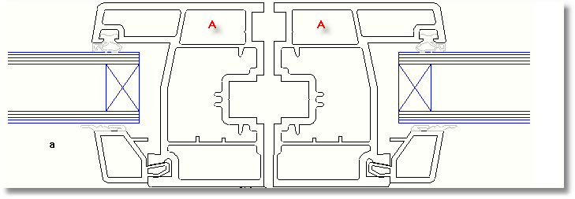
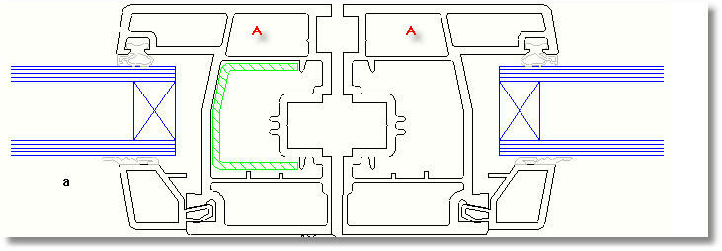
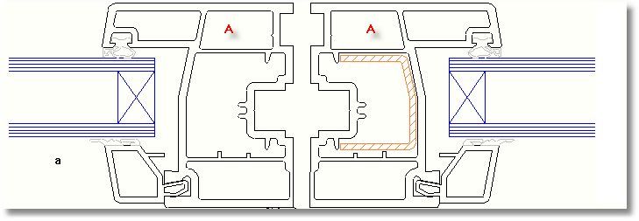
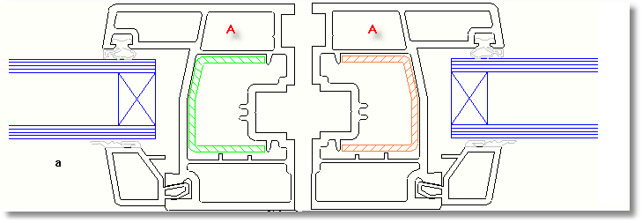
As many lines to create as possible combinations, in sequence:
Ouvrant | Renfort ouvrant | Battement | Renfort battement | Battement 2 | Renfort battement 2 | Renfort ouvrant 2
A
A | Reinf. A
A |  |  |  |  |  | Reinf. A
A | Reinf. A |  |  |  |  | Reinf. A

    - Case 2 : 2 identical sash profiles for each leaf, one single French mullion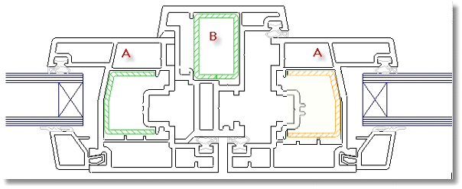
One line required for each profile/reinforcement combination, and for the below case
Sash | Sash reinf. | French mullion | French mullion reinf. | French mullion 2 | French mullion reinf. 2 | Sash reinf. 2
A | Reinf. A | B | Reinf. B |  |  | Reinf. A

    - Case 3 : 2 identical sash profiles for each leaf, two French mullions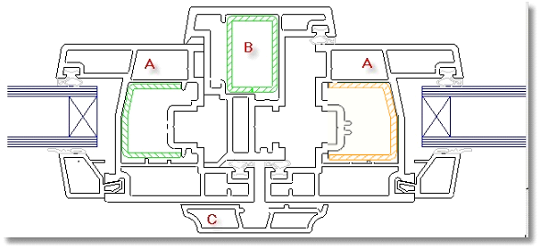
One line required for each profile/reinforcement combination, and for the below case
Sash | Sash reinf. | French mullion | French mullion reinf. | French mullion 2 | French mullion reinf. 2 | Sash reinf. 2
A | Reinf. A | B | Reinf. B | C | Reinf. C | Reinf. A
A | Reinf. A | C | Reinf. C | B | Reinf. B | Reinf. A

Case 4 : 2 distinct sash profiles for each leaf, no French mullion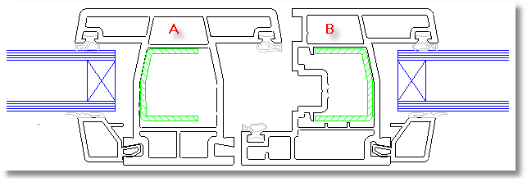
One line required for each profile/reinforcement combination, and for the below case
Sash | Sash reinf. | French mullion | French mullion reinf. | French mullion 2 | French mullion reinf. 2 | Sash reinf. 2
A | Reinf. A
B | Reinf. B

    - Case 5 : 2 distinct sash profiles for each leaf, one single French mullion 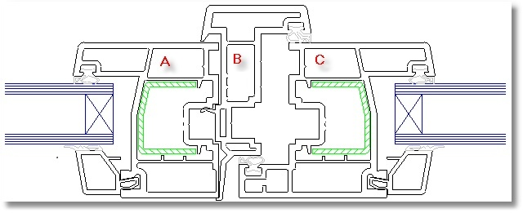
One line required for each profile/reinforcement combination, and for the below case
Sash | Sash reinf. | French mullion | French mullion reinf. | French mullion 2 | French mullion reinf. 2 | Sash reinf. 2
A | Reinf. A | B | Reinf. B
C | Reinf. C | B | Reinf. B

    - Cas 6: 2 distinct sash profiles for each leaf, two French mullions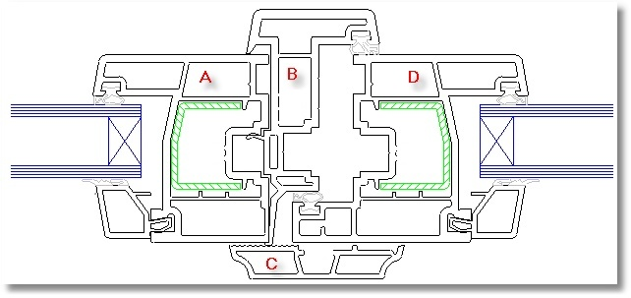
One line required for each profile/reinforcement combination, and for the below case
Sash | Sash reinf. | French mullion | French mullion reinf. | French mullion 2 | French mullion reinf. 2 | Sash reinf. 2
A | Reinf. A | B | Reinf. B | C | Reinf. C
D | Reinf. D | C | Reinf. C | B | Reinf. B

Important notes :
- Cut-throughs showned here are samples corresponding to the various combinations.
- The sequence used to declare profiles is important, as the software will consider this sequence to determine the correct profile combination used, particularly for cases 3 and 6.
- For the computation to be correctly processed by the program, it is imperative that the profile rules are set correctly. Thus, sash frame profiles have to belong to the Main profile category, and French mullion profiles must belong to the French mullion category ! Every profiles set should also belong to the correct frame level, at the appropriate frame side, otherwise computation will return incorrect values !

Once those elements fetched, the program generates a search key and use it for seeking into the U_{f} values table.This implies then that French mullion profiles must be set up correctly to the appropriate sash frame, in particular when 2 French mullion profiles are used into the same pane type.

Door bottoms
This dialog is similar to the frame + sash dialog, with replacing outer frames with a door sill or a kaltefeind.

Ventilation grid
The program takes consideration of ventilation grids during thermic computation. Fot this, you need to create two variables for profile(s) receiving the grid hole:
CoeffU_VMC : stores the thermic coefficient of the ventilation grid.
SurfaceVMC : stores the total surface calculated for the ventilation grid, into mm².
E.g. for a 10mm grid hole diameter, the surface would be , considering WinPro’following computation : 4 * Pi () * Square (10/2)
WinPro retrieves the surface of the ventilation grid. The surface is deduced from the surface of the profile receiving the grid. Then the program compute the product of the ventilation grid’ surface (converted to m²) by the grid coefficient.

Glass units table
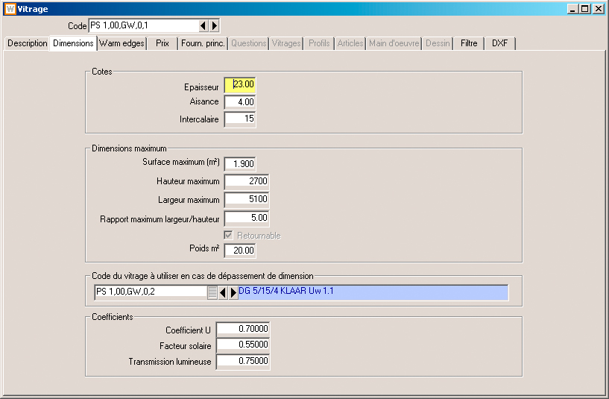
This table contains additional settings for correct calculation of thermic coefficient of a window or door:
U coefficient: thermic coefficient of the glass unit.
Attention! For composed glazing, this value can only be set through formulas (variable Ug).
Solar factor: Coefficient of solar energy transmission for the glass unit.
Light transmission: coefficient of light transmission for the glass unit.
Both settings are not used during thermic computation, but are shown as indication along with the description of each glass unit.

Panel units categories
This table can be accessed via menu Technic | Windows | Panels category
Those categories will make the set up of Ψ_{p} values (peripheral coefficient for panels) easier, for simplified as for detailed values. A category will have to be assigned for each panel unit, and will be used to fetch necessary values for thermic calculation: either the simplified Ψ_{p} value, or the relevant index number into table of detailed Ψ_{p} values.
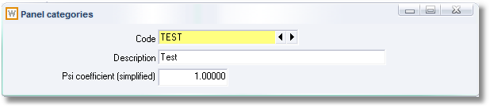
- Code : code of the category
- Description : description of the category
- Psi coefficient (simplified) : similar usage as glass units.

Panels tables (standard panels, decorative panels, composed panels)
Those tables contain additional settings for correct computation of the thermic coefficient for a window or door:

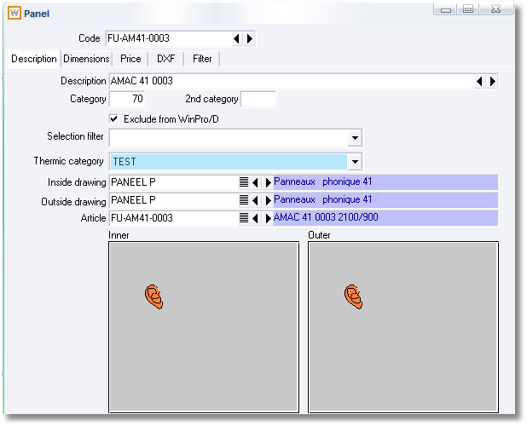
Thermic category: sets the panel category for thermic computation (See below Panels category). All panel types are supported.

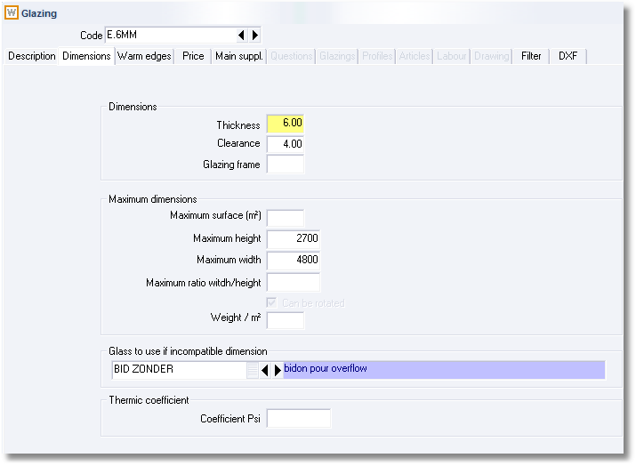
U Coefficient: thermic coefficient for the panel.
Attention! This value is set for standard panels and decorative panels only. For composed panels, you will have to define this value by formulas (variable Up).

Ventilators table
This table contains additional settings for correct calculation of thermic coefficient of a window or door:
Caution!!! Thermic computation including ventilators is disabled by default. For the program to consider the ventilator within below described calculation, add the following section and key into settings table:
[Thermique]
Aerateurs simplifies=0
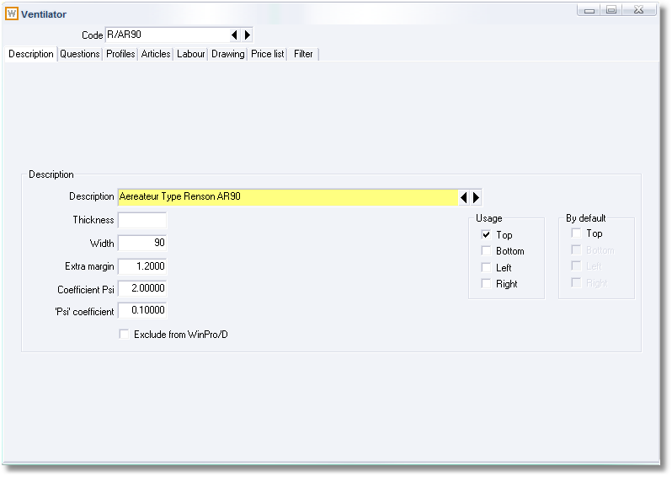
U coefficient: thermic coefficient for the ventilator
‘Psi’ coefficient: peripheral coefficient of the ventilator. Attention, this coefficient is applied for the whole ventilator perimeter, and then replaces the Ψ_{g} of the glazing, at the interface between the glass unit and the ventilator.

Glazing bars table
This table contains additional settings for correct calculation of thermic coefficient of a window or door:
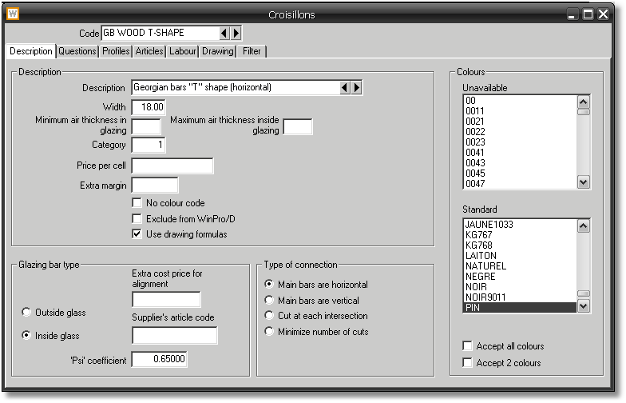
‘Psi’ coefficient: linear coefficient of the glazing bar (Ψ_{Sp}).
The Ψ_{Sp} coefficient will be applied onto the length of the bars of the Georgian frame. This length is automatically calculated and stored by WinPro; it can be redefined by rule, with assigning the PsiLn variable into glazing bars formula, in order to take in consideration the eventual glazing bars drawing formulas you may have created.

Integrated roller shutter boxes
The set up of thermic values for the roller shutter boxes depends on variables and input options, which make the calculation using fixed values impossible. You may then have to set by rule a Ψ value that will be recorded into a Psi labelled variable. The value of the Psi variable will correspond to one of the values of array 1 (see above). If this variable is not initialized properly, or is null, WinPro will apply the maximum Ψ coefficient, value would then be 1.5.

Integrated roller shutter curtains
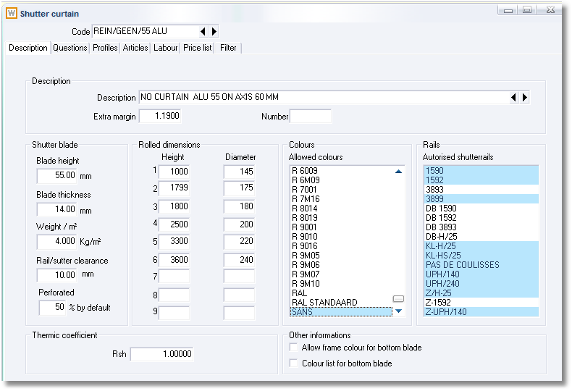
The R_{sh} value, which represents the thermic resistance of the design, will be available after setting a fixed value into the curtain file. This value may be changed afterward, with setting the RSH variable into a curtain formula. If the variable is left as null, and the fixed value is not defined, the program will consider the most disadvantageous value, R_{sh} = 0.
The class of thermic resistance for shutter curtains will exclusively be assigned through a ThermicClass variable, to be defined into curtain formula, accordingly table 2 (see above). If the variable is not set, or set with a value lower than 1, WinPro will automatically assign 1 to the variable (most disadvantageous case). If the value is greater than 5, WinPro will assign a value of 5. In case the variable value is a decimal number, it will be rounded to the nearest integer number.

Thermic module usage
The use is particularly simple.
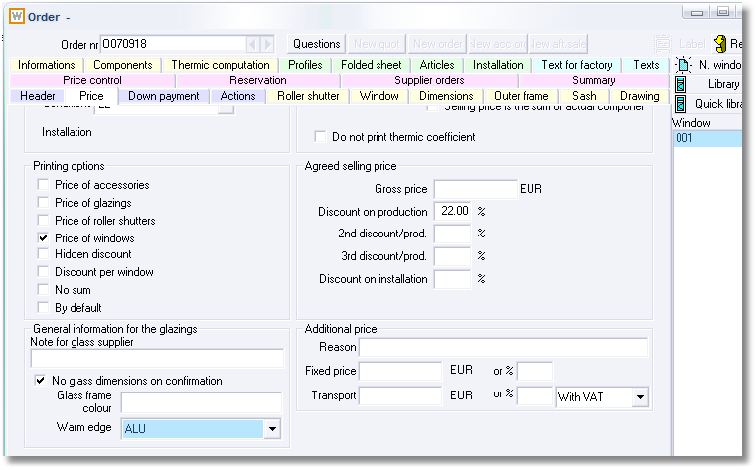
You may simply disable the thermic computation, checking the box labelled ‘Do not print thermic coefficient’
See also above for the warm edges usage feature.
That’s all you need to do for the input operation!

The thermic calculation results may be checked into 4 locations:
Into the ‘Order summary’ tab: an additional column Uw indicate the calculated values by window. At the bottom left area for total price, an additional line displays the average balanced value for the overall order. In case of computation error (missing setting), question marks (???) will be displayed in place of the thermic values.
Into the new ‘Thermic computation’ tab. This tab of the order displays a full detail of the computation, for glass unit or panel unit, and their surrounding profile sets.
Screenshot:
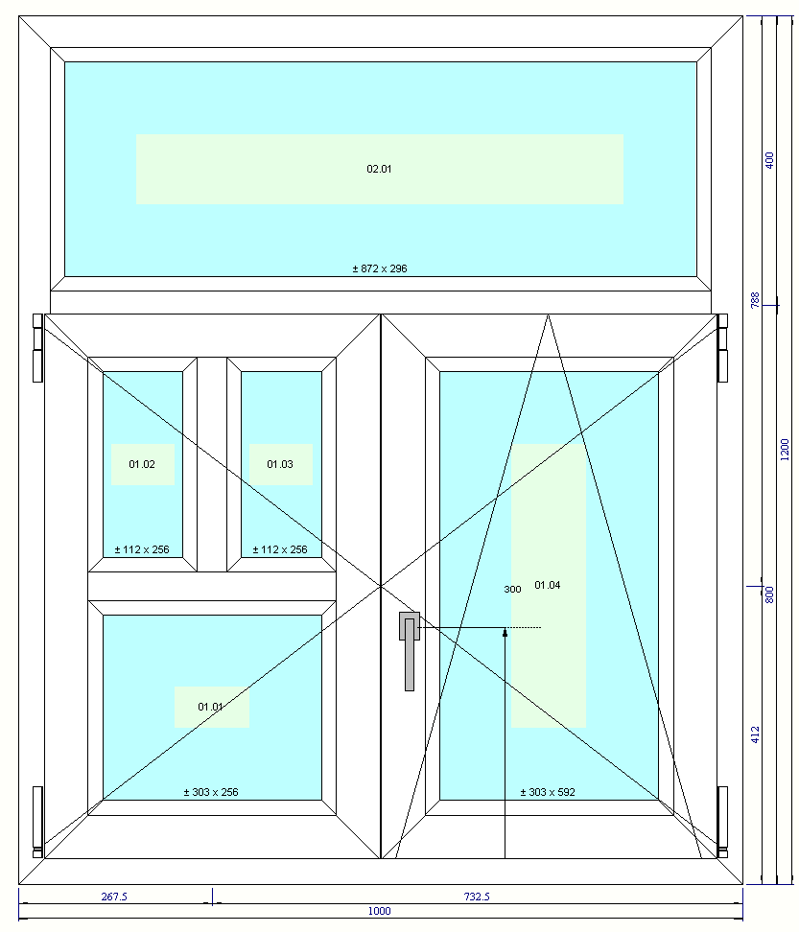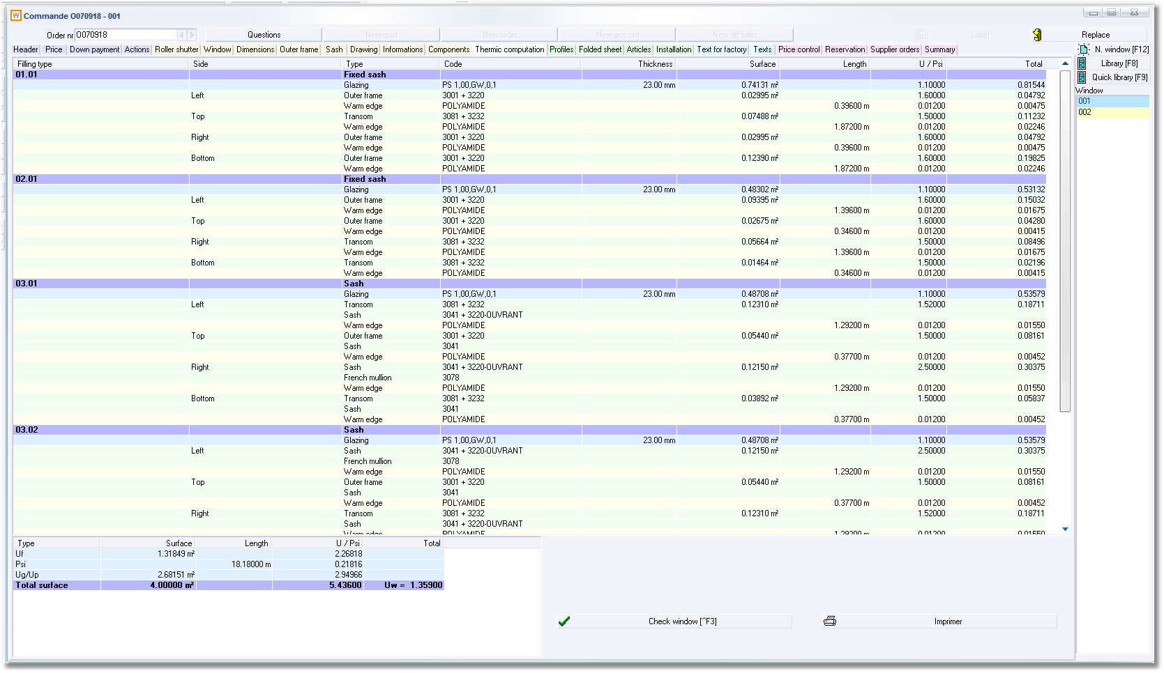

In case of error, the incorrect line will be highlined in red colour, with the ‘Error’ label at the beginning of the line.
Example :
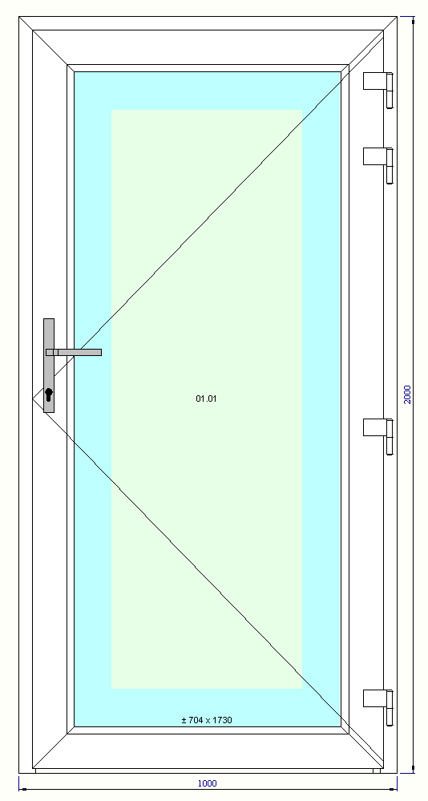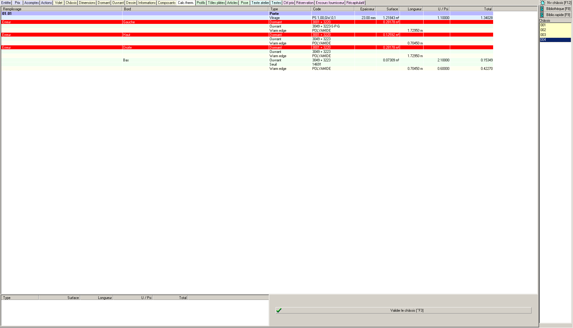

Onto customer documents. The thermic value by design is printed among the description, into a dedicated area. A summary is also printed at the end of the document, listing every design with individual value, surface and quantity. This summary also displays a global balanced value (sum of values of each design multiplied by each respective quantity, the sum is then divided by the total surface of all designs).
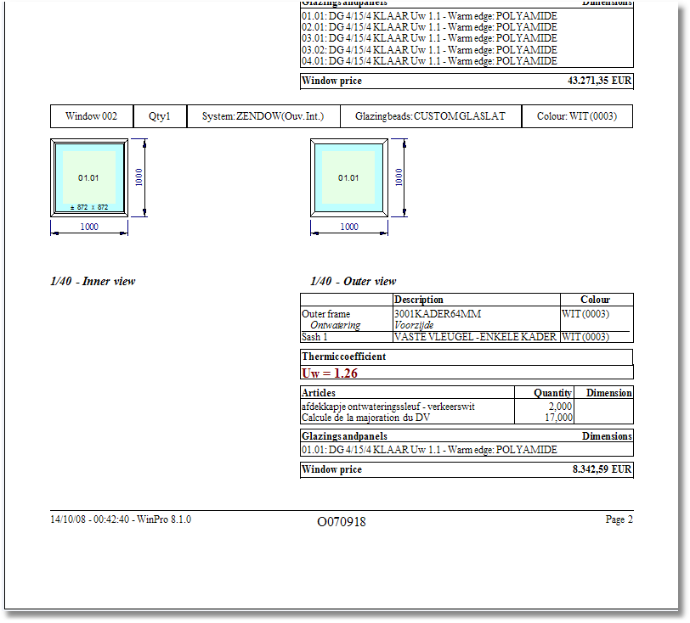
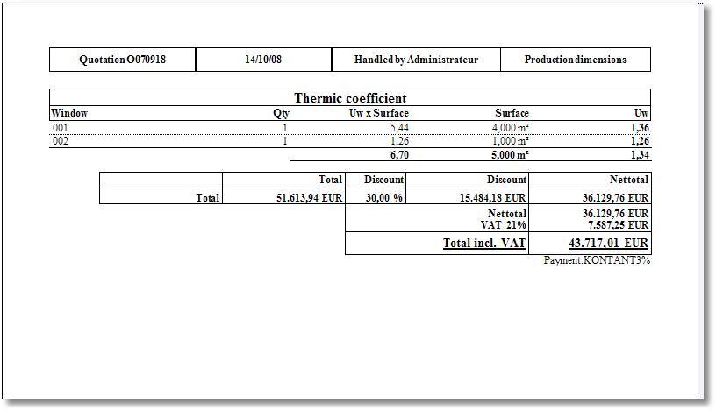

Ujn (day/night coefficient)
In Belgium and France, a notion of ‘day/night’ coefficient exists, labelled Ujn.
This coefficient applies onto combinations of windows and incorporated roller shutter.
This value is computed as follows:

France :
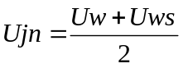

Belgium :
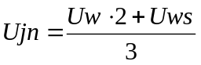

In order to allow WinPro to apply the right formulae for the right customer, a global variable has to be set, as follows:
_FormuleUjn := x
Replacing x with 0 for France, 1 for Belgium. Any other value will be ignored.

If you wish to use always one of both formulae, simply set the variable _FormuleUjn at the site variable level of the set up (menu Tools | Preferences…). If you wish to make this rule vary according the customer code, set this variable at the customer record level rather than at site formulae level..
Please note that when this value is not set, or set with a value other than 0 or 1, the Ujn wouldn’t be nor computed, neither mentioned onto documents.

Limitation of computation for the thermic module
Using 8.1 versions, the computation can be granted as correct for every rectangular window.
For trapeziums and triangles, some minor gaps may be encountered comparing with the theoretical calculation (error related to the evaluation of the surface for profiles corners).
For others shapes, the computation is more approximated, and cannot be granted.
Designs including empty spaces are not correctly handled (missing calculation of the loss for semi-transom beside an empty space)
Those problems should be solved into the following releases.

Calculation accuracy for the thermic module
The computation is done using floating point numbers, according norm IEEE-754 over 64 bits (around 15 significant digits). Internal memory computation is done over 80 bits. Basic values may be set with over a maximum of 5 decimals, as well as for intermediate values, but the full decimals are used during internal computation. The final result is rounded on 2 decimals at the nearest value (4-5 rounding). Attention, some rounded value may seem to be wrong, but are most probably correct. For instance, a value of 1.4449999 would be rounded to 1.44 using a 2 decimals display format, but rounded to 1.445 with a 3 decimals display format, and to 1.44500 using a 5 decimals format.

Guarantees for thermic module
Everything has been done aiming to offer an exact computation of the thermic performance for windows, based on coefficients customized by users into the program.
Nevertheless, none programs having none computation errors, we fully detail the computation for each window.
Indeed, mainly two kinds of errors may occur: either a software error, in case the program meets a not programmed situation; or a data error, in case the user made errors when inputting thermic values of components.
We then recommend that you check the computation values for every quote or order when those values have a critical importance. For that, we supply a complete, clear and accurate control tool, and then any responsibilities will be declined in case of error. We are engaged in correcting the software once the error is reproduced and analyzed by our services.

Doubled windows
This module is currently at finalization stage and will be documented further later.

Definition
A window is advertised by the name of doubled window when 2 sash frames are installed one in front of another (paralleled), into the same outer frame. That sort of product is mostly wide spread into northern countries and East European countries.
Samples of doubled windows, photographed at Warsaw:
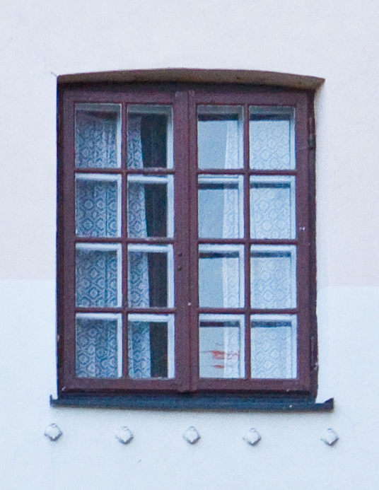

Data set up
A doubled window is basically set up and input like two single windows, with a common outer frame.
The main thing to do is only to enable the feature at the outer frame set up level.
At the formula level, you may use a variable labelled DoubleWindow, available at sash and fittings frame levels:
0 = no doubled window
1 = inside window
2 = outside window
The concept of inside/outside windows is set for a design viewed from inside. In case the design is input viewed from outside (system property), value 1 will be set for the outside window, 2 would be set for the inside one.
In order to avoid ambiguous reference, we will label the inside window as main window, and the outside window will be labelled as slave window.
At the milling operations point of view, nothing particular should be done for such feature. Millings code from sash or fitting frames toward the outer frame are available for both windows. Millings from a sash frame toward itself, or from a fitting frame toward a sash frame are based on the original window where the milling were generated, and will reach the corresponding sash frame (millings from a sash or fitting frame within a main window will reach the main sash frame, millings from a slave window will reach the slave sash frame).

Usage

Input
The input stage for such a product is very simple, but it is better to start with inputting the outer frame elements (outer frame itself, O/F transoms, peripheral profiles, roller shutter), before taking care of sash frames. Anyway, WinPro would be able to adapt the respective sash frame of each facet of the design, in case the outer frame is modified afterward.
The main window is input normally, like usually for a basic window.
For the slave window, a right click into the list of designs (right side pane of the order) will show a new context menu suitable for adding a 'Doubled window'. WinPro will then create a second record into the list of window, which will contain the slave window specifications. Anything may be modified at this step, except the outer frame settings.
Please also not that a right click onto a slave window will have no effects. Also, when a slave window is already defined, a right click onto the main window will not allow the user to input a slave window again. Finally, if you wish to delete a slave window, simply delete the main window.

Computation
The slave window won't be edited separately onto a specific document; it will be edited along with the main window. For instance, assembly list documents will be printed with both slave & main windows into the same layout. But in order to correctly identify the components, the slave window components will be printed just after the main window last component, as well as for the Component tab of the order.

Drawings
Sash frames are drawn according the view orientation defined into the system, and according their visibility regarding this view. It i possible to print both sashes with printing both views onto documents systematically.

Cut throughs
This feature is not available currently and will be developed later.

Marking feature

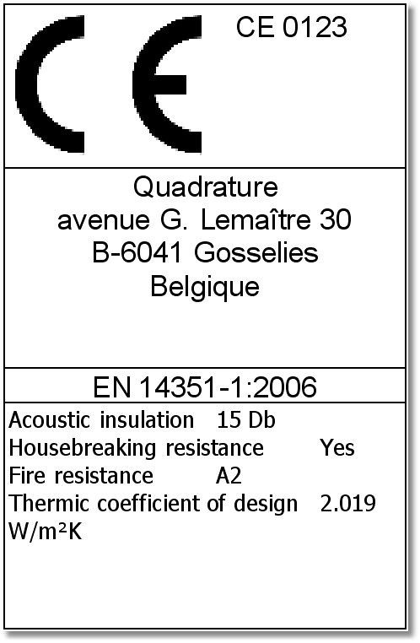

Definition
The new marking module is design to answer your legal obligations regarding marking, in an automated way.
This module allows the set up and printing of any imperative disclosure about the marking. Note that the content of this mark remains under your full responsibility, Winpro only supplies the necessary mechanisms, as well as a printing format meeting legal requirements.

Set up
CE marking feature is a 2 levels set up.
The first level allows to define different type of mark, according for instance the window types (door, casement, slider, … into PVC, aluminium, wood, …), the production site, the destination country, etc…
At this set up level, a record needs to be created for each mark type, through menu Technic | CE Marking.
Each record is composed of two pages. The first one consists in fixed data for each mark (field in bold are necessary !) :
- Description : set here the design type, e.g.. ‘PVC casement’.
- Category : random numeric value, which just needs to be different for each mark
- Identification number (optional)
- Name and address of the company applying the mark
- Certification number (optional)
- Identification of the corresponding norm
- A variable name should be created here (without « _ »), in order to retrieve the thermic coefficient Uw of the design, as it is computed by WinPro (in case you use the thermic module), or as it is computed through user defined formulas along the design computation. Refer to point 2 of the second set up level below.

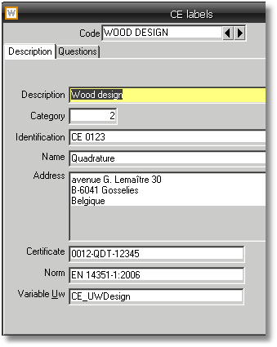
The second page is a list similar to the existing list of questions met into the technical set up.
The differences with existing question sets are : in a fist hand, a new column is added for a ‘Unit’ value, for settings requiring a measure unit (e.g. for the thermic computation, the unit would be ‘W/m².K’); in a second hand, those ‘questions’ are not accessed straight by the user into the interface as for standard questions, as answers will have to be set by programming it only.
The second level consists in using those pseudo-questions defined at the set up level, into formulas. This is done in a 2 steps way:
- First, the mark to use with a particular design has to be set. This is to be done before the design computation, but after WinPro has initialized the global variables related to this design. Then, the mark type should be set into one of the below formula:
  - Site formula
  - User formula
  - System formula
  - Customer specific formula
The selection of the mark type is done by assigning a value for variable _CEMarking; this value will be used as a search key for the mark type, corresponding to the content of field Category.
Sample of system formula
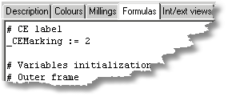
- Into the data set up itself, you may modify the variables for questions defined at the mark level, with your suitable values. Note that all marking variables are considered as global variables, question variables or answer selection variables.

Example of questions creation (variable names without « _ »)
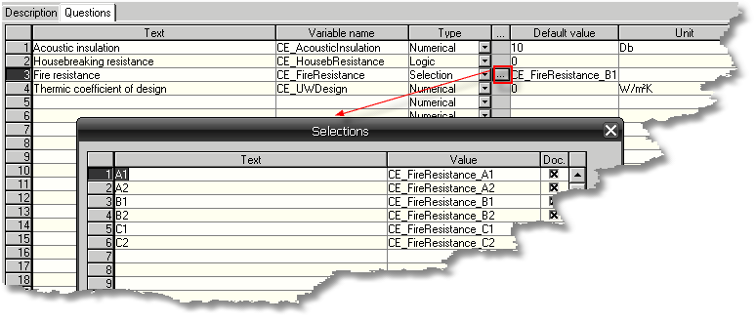
Example of questions usage into a fittings frame (variable names with « _ »)
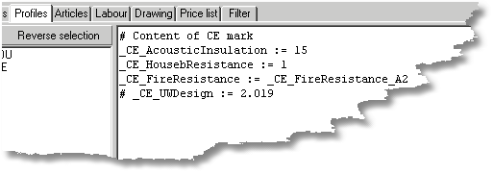

The modification of default values defined for questions must imperatively be done from a tab where components are computed (article, profile, …).
It is then prohibited to assign variables for questions from:
- The Formula sub-tab from the Supplier tab of a glass unit record
- The Round up glazing tab of a Supplier record
- Questions formulas
- Filters formulaes
- The site, user, system and customer specific formulas
However, as an exception, it is anyway possible to modify questions values for CE marking from customer discount formulas.

Note :
To be able to retrieve a thermic coefficient Uw for the design, you must have created first a variable name into the Description tab of the CE label, as seen previously.
A question labelled with this variable name must then be created into the question tab, with numerical format (it is better to set a measure unit, as well as a zero default value for this option).
When the variable is not altered manually by the user along the design formulas computed, the created variable will retrieve the thermic coefficient as computed by WinPro, if the thermic module is available into your licence.
When the concerned variable is altered along design formulas (see above screenshot), the new assigned value will be retrieved into the option.
This in order to allow a manual thermic value without the whole and finalized thermic module set up.

At the end of the computation, meaning when all rules related to the windows are executed, the variables for questions are retrieved, and the final set of questions/answers is stored into table DETAIL2, ready for printing labels at the optimization stage.
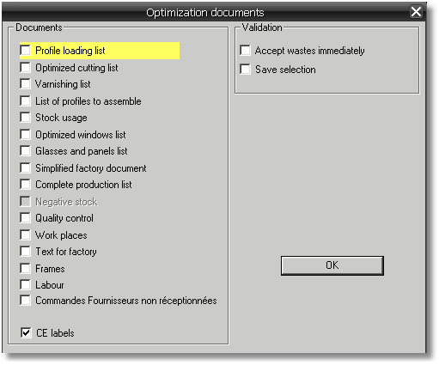
You will then be able to use information related to the marking into WpReport, or any reporting software.
Note that the document used for printing labels is set a standard WPR document labelled « CE labels », you may create any needed copy using the button ‘Standard report’ from WPR
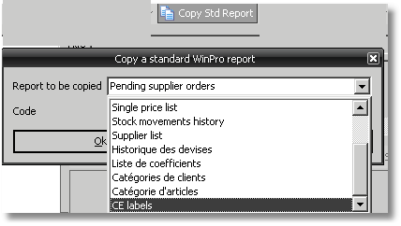
Also, when sending an order or quote into export table (when printing a customer document set with a data export for instance), various new fields into FEN table will contain options printed onto label, including the set of questions/answers, along with the others details as the address, the certification number, etc…, this in order to store information as defined when the order was recorded.

This new feature has lead us to lightly modify the initial computation sequence for global variables into WinPro. The initial computation sequence was :

1. Overall variables (dates, wall configuration, ...)
2. Site formulas
3. User formulas
4. System formulas
5. Window configuration and description variables
6. Customer specific formulas

The new computation sequence is now:

1. Overall variables (dates, wall configuration, ...)
2. Window configuration and description variables
3. Site formulas
4. User formulas
5. System formulas
6. Customer specific formulas
7. marking variables

The _CEMarking variable should be defined before step 7, then into a site, user, system or customer formula. It was in fact necessary to be able to test the window configuration variable into the above mentioned formulas, that is the reason why those configuration variables are now computed at step 2 into the computation sequence.

Mise en place
Several new keys are created into settings table, in order to manage with the label format and the feature behaviour, among :
[Label CE] ; labels format
Height = XX ; label height, into mm (type integer I)
Width = XX ; label width, into mm (type integer I)
Top Margin = XX ; label top margin, into mm (type integer I)
Bottom Margin = XX ; label bottom margin, into mm (type integer I)
Left Margin = XX ; label left margin, into mm (type integer I)
Right Margin = XX ; label right margin, into mm (type integer I)

[Optimisation] ; overall settings related to optimization
Label CE ; set to 1 tu default check the printing box for CE labels at optimization stage, zero to default uncheck the box (type integer I).

[Export Groupe] ; settings for grouped printings at optimization stages
Label CE ; 1 to allow a grouped (silent) printing of the CE labels after optimization, without using the document selection dialog, zero otherwise (default value, standard WinPro behaviour, key of type integer I)
For the whole related key, please take a particular care to the syntax and spelling as keys are case sensitive, and you may not be able to print your labels in case of a wrong set up.
We also designed a procedure to apply the CE marking to orders created after the module has been set up. To compute the marking settings for those orders, simply run WinPro under command line with below described switch :
WinPro /ce yyyymmdd
The second switch yyymmdd is the date when the orders have been created. With this optional switch, WinPro will compute the CE marking to all orders created before or including this date; the date switch is to be declared with year month day format, without separator, and with the century (e.g. 20090901 for September the first of year 2009). When the date switch is not set, WinPro will compute CE marking for all orders.
A 'logCE.txt' file is also created, containing for each order line the order number, the design number and the CE marking applied, for you to quickly check the result!

condition for the insulation layer: Risol ≥ 0,5 m²K/W
Ψ value to be added to the thermic transmission through the frontage element where the shutter box is installed as product of the Ψ value with the length (l) of the shutter box;
remaining slot at the inferior side of the shutter box: 2 < b ≤ 10 mm
remaining slot at the inferior side of the shutter box: b > 10 mm
ΔR values are correct for Rsh < 0,3 m²K/W (Rsh is the thermic resistance of the roller shutter itself, determined according NBN EN ISO 6946 in case the roller shutter is composed of homogeneous material, according NBN EN ISO 10211 in case of heterogeneous composition, or according EN ISO 10077-2 in case of a designed box profile). For unknown roller shutters, the resistance value may be ignored: Rsh = 0 m²K/W.
This case involves the usage of closing gaskets along at least 3 sides of the roller shutter, and the remaining slot should be strictly under 3mm
Class 5 (very low permeability) may also be used if the air flow measured through the closed roller shutter is not above 10 m³/h.m² (with a difference of pressure of 10 Pa – reference according NBN EN 12835). Additional conditions for class 5 may be found into NBN EN 13125 by roller shutter type.
Concerning more important thickness of the space gap between windows, the Rs value should be determined based on calculation method from norm ISO 15099, or on a numeric calculation or on tests.

